Module-3 Critical Thinking Assignment
Option-1: Linear Regression Model for Predicting Noisy Numerical Data

Jibran Gill
Colorado State University Global
CSC580 – Applying Machine Learning and Neural Networks - Capstone
Dr. Bingdong Lee

Table of Contents
Introduction 3
Methodology 3
Data Generation and Preprocessing 3
Model Construction 4
Loss Function 4
Training Process 4
Visualization and Interpretation 5
Left Panel Showing Training Data 5
Right Panel Showing Training Data with Fitted Regression Line 5
Results and Observations 5
Model Convergence 5
Learned Parameters 5
Prediction Accuracy 6
Visualization Confirms Proper Fit 6
Conclusion 6
References 6
Appendix-A: Program Source Code 7
Appendix-B: Program Outputs 9
oneDNN custom operations Warning: 9

Option-2: Linear Regression Model for Algebraic Equation Prediction

Introduction
This report presents the implementation of a TensorFlow-based linear regression model designed to learn and predict values from noisy one-dimensional synthetic data. The assignment required using TensorFlow operations, defining trainable variables, computing gradients manually using GradientTape, and visualizing both the dataset and the fitted regression line. The purpose of this exercise was to reinforce understanding of gradient descent optimization, loss computation, variable updates, and fundamental supervised learning workflow without relying on high-level Keras abstractions.
The experiment demonstrates key machine learning concepts including data generation, manual optimization loops, variable tracking, convergence behavior, and model visualization.

Methodology

Data Generation and Preprocessing
To simulate real-world noisy data, the program generated 50 evenly spaced values between 0 and 50 for both x and y using numpy.linspace. Random uniform noise in the range −4,4-4, 4−4,4 was added to both arrays to break perfect linearity and provide realistic variance for regression.
Random seeds were fixed for both NumPy and TensorFlow to ensure deterministic reproducibility:
- np.random.seed(101)
- tf.random.set_seed(101)
The dataset did not require scaling because the values are already within a manageable numerical range.

Model Construction
A simple linear regression model of the form:
$$ŷ=Wx+b$$
was constructed using two TensorFlow variables:
- Weight (W), randomly initialized scalar
- Bias (b), randomly initialized scalar
A gradient descent optimizer (tf.optimizers.SGD) with a learning rate of 0.01 was used to iteratively minimize the mean-squared error loss function.

Loss Function
The cost function was defined as:
$$J\left(W,b\right)=\frac{1}{2n}\sum_{i=1}^{n}{{\left(Wx_{i}+b-y_{i}\right)}^{2}}$$
where n is the number of data points.

Training Process
Training was performed over 1000 epochs using a manual gradient descent loop implemented with tf.GradientTape.
Steps performed each epoch:
- Compute predictions y_pred = W * x + b.
- Compute cost using mean squared error.
- Use GradientTape to compute gradients with respect to W and b.
- Apply gradients with optimizer.apply_gradients.
- Log progress every 100 epochs.
This approach reinforces the mechanics of gradient-based optimization at the tensor level, similar to how frameworks operate internally.

Visualization and Interpretation
To provide clear comparison, a two-subplot figure was generated:

Left Panel Showing Training Data
A scatter plot showing raw noisy data points.

Right Panel Showing Training Data with Fitted Regression Line
Includes:
- Training data points
- Best-fit line learned after training
- Legend displaying:
  - Learning rate
  - Epoch count
  - Optimizer name
  - Final cost
  - Final weight
  - Final bias
This visual consolidation allows easier interpretation without switching between terminal and graph outputs.

Results and Observations

Model Convergence
The cost decreased consistently over epochs, showing smooth convergence typical of simple linear models.

Learned Parameters
- Final Weight (W) and Final Bias (b) were optimized to best fit the noisy dataset.
- Values are displayed in both the legend and terminal output.

Prediction Accuracy
The fitted line visually aligns with the underlying noisy trend, illustrating successful learning despite randomness in the data.

Visualization Confirms Proper Fit
The final regression line cuts through the center of the noisy scatter pattern, demonstrating that gradient descent successfully minimized error.

Conclusion
This assignment successfully demonstrated the construction and training of a linear regression model using low-level TensorFlow operations. The implementation reinforced concepts including:
- Variable initialization
- Gradient computation using tf.GradientTape
- Manual optimization loop
- Loss minimization
- Visualization for interpretation
The experiment illustrates how fundamental machine learning algorithms operate internally and provides a foundation for building more complex neural network architectures in future assignments.

References
- TensorFlow Developers. (2024). TensorFlow Core API Documentation.
- NumPy Developers. (2024). NumPy Random Module Documentation.
- Matplotlib Developers. (2024). Matplotlib Pyplot Documentation.

Appendix-A: Program Source Code
import numpy as np
import matplotlib.pyplot as plt
import tensorflow as tf

#defining fixed seeds for np and tf
np.random.seed(101)
tf.random.set_seed(101)

#generating 50 random numbers from 0 to 50
x = np.linspace(0, 50, 50)
y = np.linspace(0, 50, 50)

# Adding noise to the random linear data
x += np.random.uniform(-4, 4, 50)
y += np.random.uniform(-4, 4, 50)
n = len(x)

#training data before training
#plt.scatter(x, y)
#plt.title('Training Data')
#plt.xlabel('X')
#plt.ylabel('Y')
#plt.show()

w = tf.Variable(np.random.randn(), dtype=tf.float32)
b = tf.Variable(np.random.randn(), dtype=tf.float32)

learning_rate = 0.01
training_epochs = 1000
optimizer = tf.optimizers.SGD(learning_rate)

for epoch in range(training_epochs):
with tf.GradientTape() as tape:
y_pred = w * x + b
cost = tf.reduce_mean(tf.pow(y_pred - y, 2)) / (2 * n)

gradients = tape.gradient(cost, [w, b])
optimizer.apply_gradients(zip(gradients, [w, b]))

if (epoch + 1) % 100 == 0:
print(f'Epoch {epoch + 1}: cost={cost.numpy():.4f}, W={w.numpy():.4f}, b={b.numpy():.4f}')

print('\nFinal Results:')
print(f'Final Cost: {cost.numpy():.4f}')
print(f'Final Weight: {w.numpy():.4f}')
print(f'Final Bias: {b.numpy():.4f}')

#plotting training and fitted data graphs
plt.figure(figsize=(14, 6))

#Subplot for training data
plt.subplot(1, 2, 1)
plt.scatter(x, y, label='Training Data', color='blue')
plt.title('Training Data')
plt.xlabel('X')
plt.ylabel('Y')
plt.legend()

#Subplot for training data and fitted line
plt.subplot(1, 2, 2)
plt.scatter(x, y, label='Training Data', color='blue')
pred_line = w.numpy() * x + b.numpy()
plt.plot(
x,
pred_line,
color='red',
linewidth=2,
label=f'Fitted Line\nLR={learning_rate}, Epochs={training_epochs}, Optimizer=SGD'
)
plt.plot([], [], ' ', label=f'Final Cost: {cost.numpy():.4f}')
plt.plot([], [], ' ', label=f'Final Weight: {w.numpy():.4f}')
plt.plot([], [], ' ', label=f'Final Bias: {b.numpy():.4f}')
plt.title('Linear Regression Result')
plt.xlabel('X')
plt.ylabel('Y')
plt.legend()
plt.tight_layout()
plt.show()

Appendix-B: Program Outputs
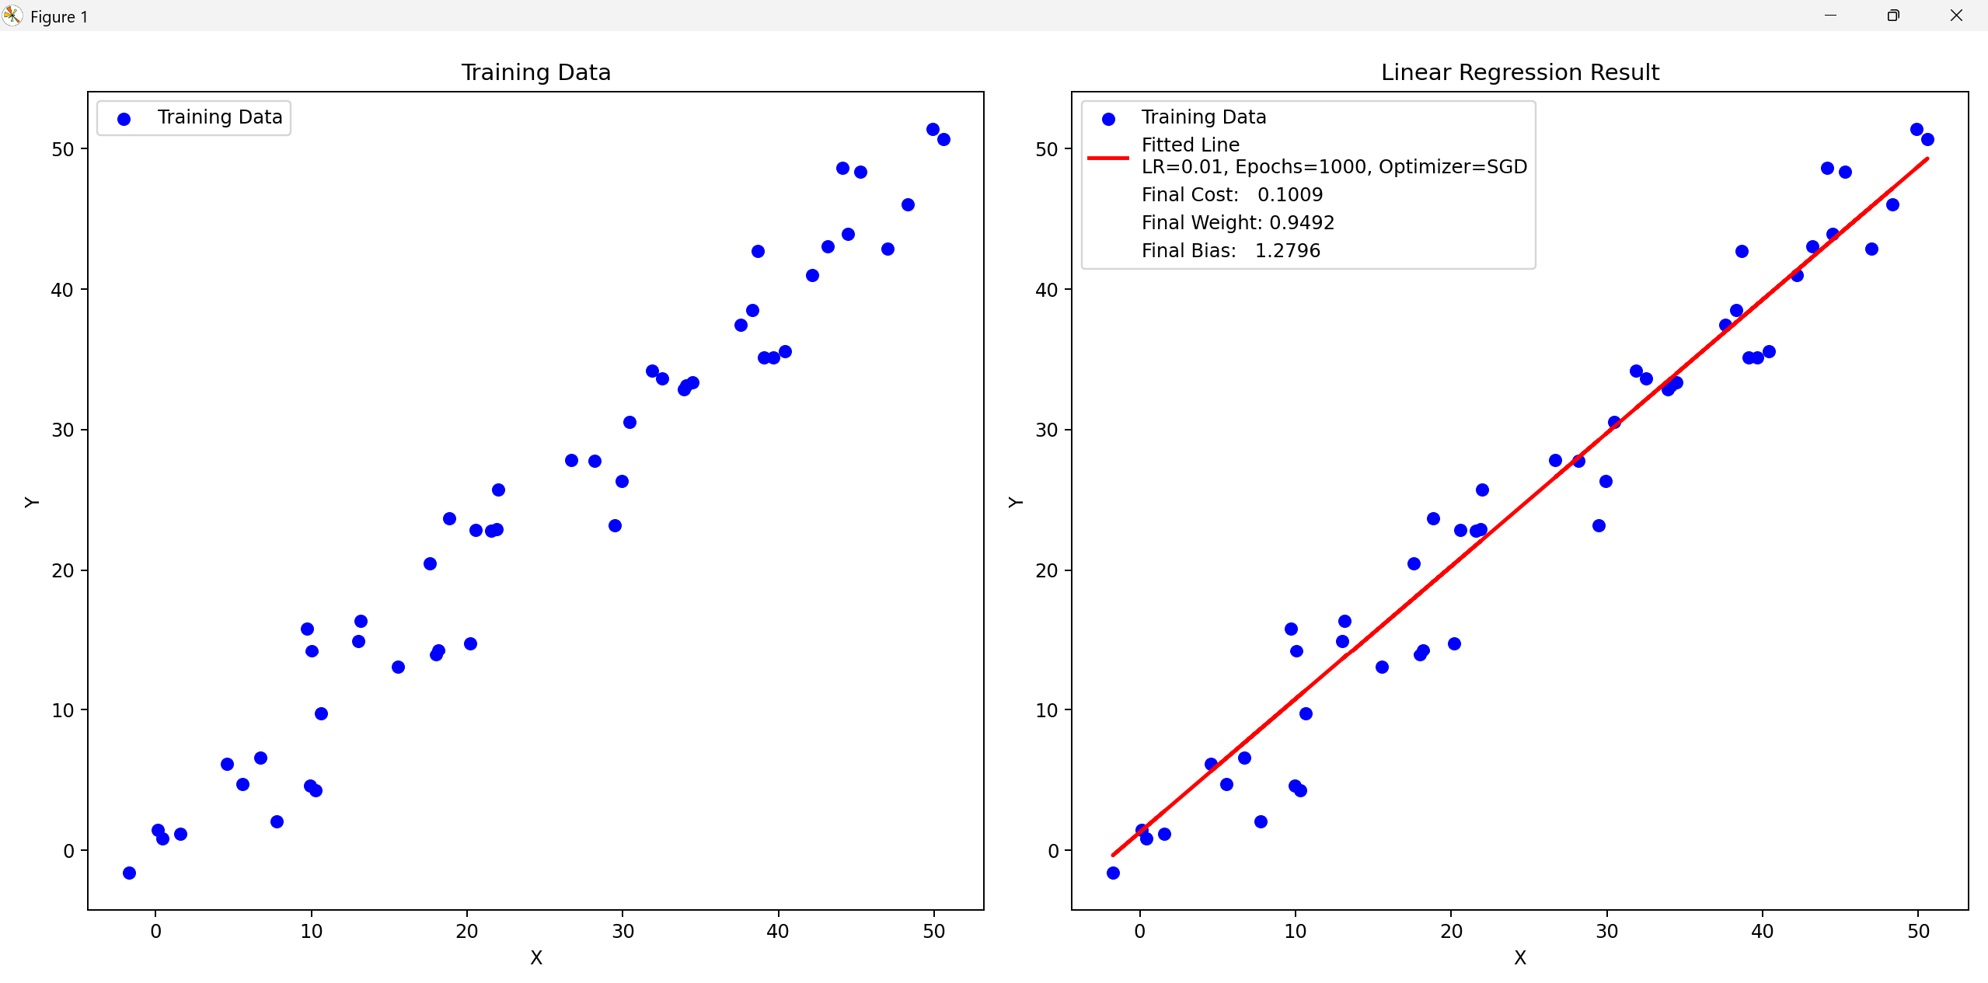
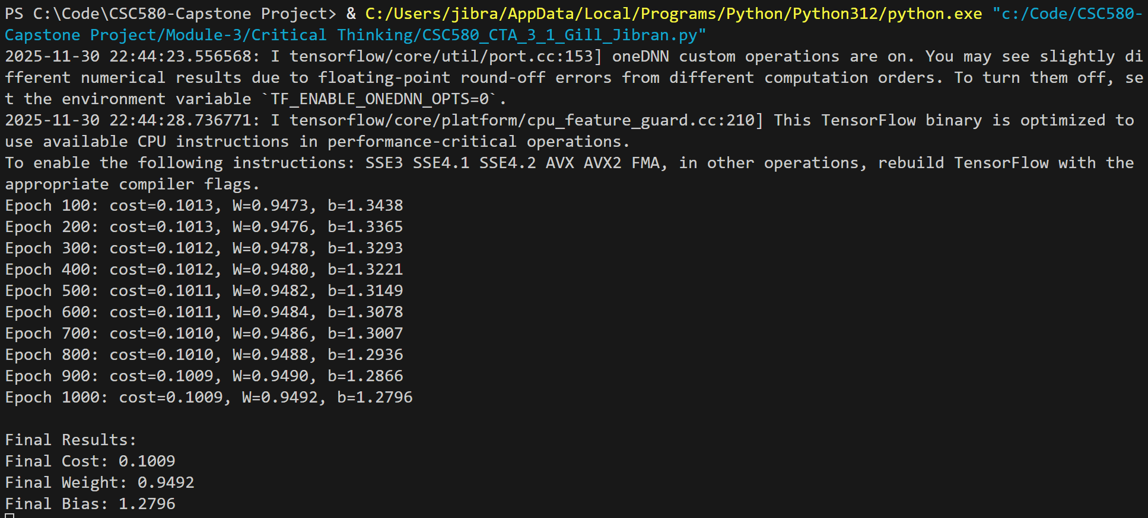

oneDNN custom operations Warning:
During program execution, TensorFlow prints the following informational message:
oneDNN custom operations are on. You may see slightly different numerical results due to
floating-point round-off errors from different computation orders. To turn them off, set the
environment variable ‘TF_ENABLE_ONEDNN_OPTS=0’.
This is not an error and does not affect the correctness of the model. The warning simply indicates that TensorFlow is using a faster, optimized computation path. If needed, oneDNN optimizations can be disabled by setting the environment variable:
TF_ENABLE_ONEDNN_OPTS=0
However, leaving the optimizations enabled is recommended for improved CPU performance.

